**Final Project Report**

**NLP Chatbot Development using Dialogflow**



**Project Supervisor**

Abdullah Qamar

**Submitted By**

F24PROJECT88F2E (BC210414987)

Hassam Khan BC210414987

**Software Projects & Research Section,**

**Department of Computer Sciences,**

**Virtual University of Pakistan**

|  |
| --- |
|  |



**CERTIFICATE**

This is to certify that Hassam Khan (BC210414987), have worked on and completed their Software Project at Software & Research Projects Section, Department of Computer Sciences, Virtual University of Pakistan in partial fulfillment of the requirement for the degree of BS in Computer Sciences under my guidance and supervision.

In our opinion, it is satisfactory and up to the mark and therefore fulfills the requirements of BS in Computer Sciences.

**Supervisor / Internal Examiner**

Abdullah Qamar

Supervisor,

Software Projects & Research Section,

Department of Computer Sciences

Virtual University of Pakistan

___________________

(Signature)

**External Examiner/Subject Specialist**

<<External Supervisor Name>>

___________________

(Signature)

**Accepted By:**

**_____________**

(For office use)

**EXORDIUM**

**In the name of Allah, the Compassionate, the Merciful.**

**Praise be to Allah, Lord of Creation,**

**The Compassionate, the Merciful,**

**King of Judgment-day!**

**You alone we worship, and to You alone we pray for help,**

**Guide us to the straight path**

**The path of those who You have favored,**

**Not of those who have incurred Your wrath,**

**Nor of those who have gone astray.**

**DEDICATION**

**I dedicate this final year project report, titled NLP Chatbot Development using Dialogflow, to my beloved family, supportive friends, and respected teachers whose unwavering support, encouragement, and guidance have been instrumental throughout this academic journey. Their constant belief in my abilities provided the strength and motivation I needed to overcome challenges and stay focused on my goals. My family’s sacrifices, emotional backing, and patience during long hours of work and study played a vital role in helping me reach this milestone. I am also grateful to my friends for their valuable feedback and to my teachers for their mentorship and knowledge-sharing, which greatly contributed to my learning. This project not only reflects the technical and practical skills I have acquired, but also symbolizes the collective effort, trust, and moral support of those who have stood by me at every stage of my educational path.**

**ACKNOWLEDGEMENT**

**I would like to express my sincere gratitude to all those who supported and guided me throughout the development of this final year project, NLP Chatbot Development using Dialogflow*.* First and foremost, I am thankful to Almighty Allah for giving me the strength, patience, and determination to complete this project successfully. I extend my heartfelt thanks to my project supervisor, Mr.** **Abdullah Qamar, for his valuable guidance, insightful feedback, and continuous encouragement throughout the project. I am also grateful to my teachers at Virtual University for imparting the knowledge that laid the foundation for this work. Special thanks to my family and friends for their unwavering support, motivation, and understanding during this journey. Their belief in me was a constant source of inspiration. This project would not have been possible without the combined efforts and support of all these individuals.**

**PREFACE**

**This project report, titled NLP Chatbot Development Using Dialogflow, is the result of my final year effort to apply theoretical knowledge into a practical solution in the field of Natural Language Processing. The objective of this project was to design and develop an intelligent chatbot for a restaurant using Dialogflow, integrating it with backend technologies such as Python and MySQL. This chatbot is capable of handling customer queries and improving communication efficiency. I would like to express my sincere gratitude to my supervisor, Mr. Abdullah Qamar, for his valuable guidance, support, and constructive feedback throughout the project. His mentorship played a vital role in successfully completing this project. This report reflects the learning, challenges, and growth I experienced during this journey.**

**TABLE OF CONTENTS**

|  |
| --- |
|  |

CHAPTER NO. 1

gathering & Analyzing info 9

1.1 Introduction **……………………………………………….10**

1.2 purpose **………………………………………………… 10**

1.3 scope **……………………………………………………. 11**

1.4 definitions, acronyms and abbreviations **…………………………...12**

1.5 use cases and usage scenarios **………………………………………. 13**

1.5.1 Use Case Diagrams **…………………………………………………. 13**

1.5.2 Usage Scenarios **………………………………………………….......14**

1.6 supplementary requirements**……………………………………… 20**

1.6.1 Usability**……………………………………………………. 20**

1.6.2 Reliability**………………………………………………. 20**

1.6.3 Supportability**……………………………………………21**

1.6.4 System Requirements**…………………………………. 21**

CHAPTER NO. 2

planning the project 22

2.1 Introduction**……………………………………………………………….23**

2.2 Methodology**…………………………………………………………….23**

* 1. Available Methodologies **…………………………………………….23**
  2. Chosen Methodology**…………………………………………………24**
  3. Reasons for Chosen Methodology**……………………………….24**
  4. Work Plan**………………………………………………………………25**
  5. Project Structure**…………………………………………………….25**
     1. Team Structure**……………………………………………………….25**
     2. Project Schedule (Submission Calendar)**....…………………………25**

CHAPTER NO. 3

designing the project 26

3.1 Introduction**................................................................. 27**

3.2 purpose**.........................................................................28**

3.3 scope **............................................................................29**

* 1. definitions, acronyms and abbreviations**............................30**
  2. Dynamic Model: Sequence Diagrams**..................................31**
  3. Object Model/Logical Model: Class Diagram**....................32**
  4. Database Model (Database Diagram) **..................................33**
  5. Graphical User Interfaces**....................................................34**

Chapter no.4

DEvelopment 38

4.1 Development plan (Architecture Diagram) **............................39**

REFERENCES **.........................................................................40**

APPENDIX **...............................................................................41**

**CHAPTER 1**

Gathering & Analyzing Info

* 1. Introduction

Chatbots are rapidly becoming an essential part of various industries including customer service, e-commerce, healthcare, education, and more. Their ability to provide instant support, handle multiple queries simultaneously, and operate 24/7 makes them highly valuable in today's digital world. In this project, students will focus on designing and developing a smart and interactive chatbot using **Google Dialogflow**, a powerful Natural Language Processing (NLP) platform that enables the creation of conversational interfaces.

The goal of the project is to build a chatbot that effectively addresses a specific business need by automating customer interactions, delivering timely and relevant responses, and ultimately enhancing the overall user experience. The chatbot should be able to understand user intent, respond appropriately, and handle common queries without human intervention. Through this project, students will not only gain practical experience in building NLP-based solutions but also understand how AI can solve real-world business problems.

To give students a focused direction, they are required to select one case study from the following three industries: **Training and Education Services**, **Pharmacy Retail**, or **Restaurant and Food Services**. Based on the selected domain, the chatbot should be customized to meet the unique requirements of that particular industry, such as booking training sessions, managing medicine inquiries, or handling food orders and reservations. This project will allow students to demonstrate their skills in chatbot design, backend integration, and user experience enhancement using modern AI tools.

* 1. purpose

The primary purpose of this project is to design and implement an AI-powered chatbot using Google Dialogflow that addresses real-world business needs through natural and efficient user interactions. With the growing demand for automation and quick response systems, especially in customer-facing industries, the project aims to develop a chatbot that enhances customer service by reducing manual workload, minimizing response time, and improving the overall user experience. By leveraging Natural Language Processing (NLP), the chatbot will be able to understand user queries in natural human language, interpret intent, and deliver appropriate responses in a conversational manner.

This project also aims to give students hands-on experience with conversational AI technologies and their application in a business context. By choosing a specific industry such as a Restaurant, Pharmacy Store, or Training Company, students will learn how to tailor chatbot features to meet the unique needs of that domain. The ultimate goal is to demonstrate how such intelligent systems can streamline operations like booking reservations, answering FAQs, or managing service requests while also providing users with a more interactive and satisfying digital experience. Through this, the project bridges the gap between academic learning and practical application of AI in real-life business scenarios.

* 1. scope

This project focuses on developing an AI-powered chatbot for the restaurant industry, designed to improve customer service and streamline restaurant operations. The chatbot will use Google Dialogflow, a powerful natural language processing (NLP) tool, to understand and respond to user inquiries in a conversational way. The primary aim is to automate essential tasks such as table reservations, order placements, and answering frequently asked questions (FAQs), enhancing customer satisfaction and reducing the workload for restaurant staff. The backend system will be built using Python, while the frontend will be developed using HTML, CSS, and JavaScript, ensuring a seamless and user-friendly interface.

The key functionalities of the chatbot include helping customers book, modify, or cancel table reservations, browse the menu, and place orders. It will also provide information about the restaurant, such as operating hours, special offers, and other common queries. The chatbot will be accessible through a simple interface, allowing customers to interact effortlessly and have their questions answered in real-time. The database, powered by MySQL, will store reservation details, customer orders, and FAQs, ensuring smooth operation and quick access to essential data.

However, the initial version of the chatbot will not include some advanced features. For example, payment processing, voice recognition, and integration with third-party delivery platforms will not be part of the first release. Additionally, multilingual support and personalized recommendations will not be available in this phase, although they may be considered for future updates. The primary focus of this project is to deliver a functional and efficient chatbot that meets the immediate needs of customers and restaurant staff, while laying the groundwork for potential enhancements down the line.

* 1. definitions, acronyms and abbreviations

|  |  |
| --- | --- |
| **Term Acronym** | **Definition** |
| **AI** | Artificial Intelligence – The simulation of human intelligence processes by machines, especially computer systems. |
| **NLP** | Natural Language Processing – A field of AI that focuses on the interaction between computers and human language. |
| **Chatbot** | A software application designed to simulate human conversation through text or voice interactions. |
| **Dialogflow** | A Google-owned platform used for building conversational interfaces such as chatbots, using NLP. |
| **FAQ** | Frequently Asked Questions – A list of common questions and answers related to a specific topic or service. |
| **UI** | User Interface – The visual part of an application that users interact with. |
| **UX** | User Experience – The overall experience and satisfaction a user has when interacting with a system. |
| **Intent** | In Dialogflow, an intent represents the purpose of a user’s input, such as booking a table or asking for a menu. |
| **Entity** | A term used in Dialogflow to extract useful data from user expressions (e.g., date, time, location). |
| **Webhook** | A tool that allows communication between Dialogflow and an external server or database to perform custom actions. |
| **Database** | An organized collection of structured data, typically stored and accessed electronically. |
| **Restaurant Domain** | The business area related to food service where the chatbot is intended to operate, handling tasks like reservations and order processing. |

1.5 use cases and usage scenarios

1.5.1 Use Case Diagrams

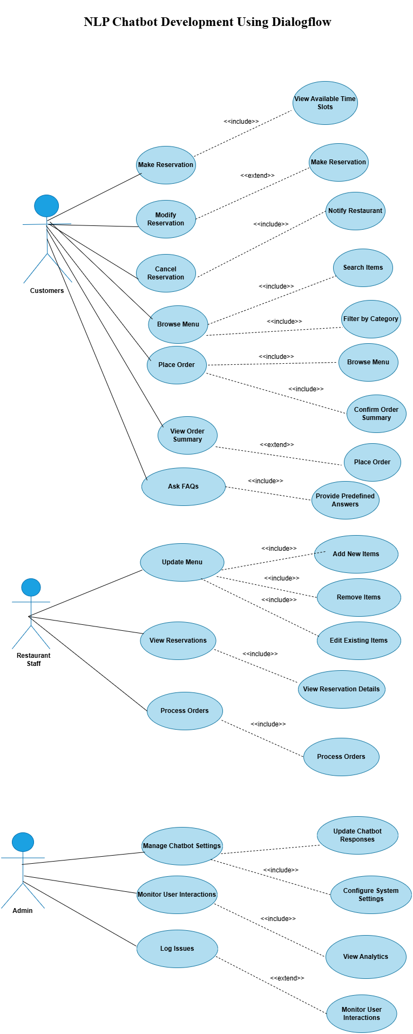

1.5.2 Usage Scenarios

### **Use Case Scenario for Customers**

#### **Make Reservation**

| **Heading** | **Description** |
| --- | --- |
| **Use Case Title** | Make Reservation |
| **Use Case ID** | UC-001 |
| **Actions** | 1. User interacts with the chatbot. 2. Provides details like date, time, and guests. 3. Chatbot confirms the reservation. |
| **Description** | Allows customers to reserve a table by providing reservation details. |
| **Alternative Paths** | 1. If reservation details are incomplete, chatbot asks for missing information. 2. If the requested time slot is unavailable, the chatbot offers alternatives. |
| **Pre-Conditions** | User is logged into the system and interacts with the chatbot. |
| **Post-Conditions** | The reservation is confirmed, and a notification is sent to the restaurant. |
| **Author** | BC 210414987 |
| **Exceptions** | Chatbot fails to confirm reservation due to unavailability of the time slot. |

#### **Modify Reservation**

| **Heading** | **Description** |
| --- | --- |
| **Use Case Title** | Modify Reservation |
| **Use Case ID** | UC-002 |
| **Actions** | 1. User requests to modify reservation. 2. User provides the updated details. 3. Chatbot confirms the modification. |
| **Description** | Allows customers to change the reservation details, such as time or guest count. |
| **Alternative Paths** | 1. User cancels the modification. 2. Chatbot asks for clarification if details are incomplete. |
| **Pre-Conditions** | A reservation has been made, and the user wants to modify it. |
| **Post-Conditions** | The modified reservation details are saved and confirmed. |
| **Author** | BC 210414987 |
| **Exceptions** | Modification fails due to unavailability of new time slot. |

#### **3. Cancel Reservation**

| **Heading** | **Description** |
| --- | --- |
| **Use Case Title** | Cancel Reservation |
| **Use Case ID** | UC-003 |
| **Actions** | 1. User requests to cancel the reservation. 2. Chatbot processes the cancellation. 3. Confirmation of cancellation is sent. |
| **Description** | Enables users to cancel previously made reservations. |
| **Alternative Paths** | 1. User decides not to cancel. 2. Confirmation of cancellation is delayed. |
| **Pre-Conditions** | A reservation is already made. |
| **Post-Conditions** | The reservation is canceled, and the restaurant is notified. |
| **Author** | BC 210414987 |
| **Exceptions** | Chatbot fails to cancel due to technical errors. |

#### **4. Browse Menu**

| **Heading** | **Description** |
| --- | --- |
| **Use Case Title** | Browse Menu |
| **Use Case ID** | UC-004 |
| **Actions** | 1. User requests to browse the menu. 2. Chatbot provides the menu or specific categories. 3. User selects items to view. |
| **Description** | Provides the customer with an option to explore the menu items, filtered by categories. |
| **Alternative Paths** | 1. User asks for a specific item. 2. User browses by categories like vegan, gluten-free. |
| **Pre-Conditions** | Menu items are preloaded in the system. |
| **Post-Conditions** | User views menu details or receives item suggestions. |
| **Author** | BC 210414987 |
| **Exceptions** | Menu fails to load due to system errors. |

#### **5. Place Order**

| **Heading** | **Description** |
| --- | --- |
| **Use Case Title** | Place Order |
| **Use Case ID** | UC-005 |
| **Actions** | 1. User selects items from the menu. 2. User confirms the order. 3. Chatbot processes the order. |
| **Description** | Enables customers to place their food orders through the chatbot. |
| **Alternative Paths** | 1. User modifies the order before confirming. 2. User cancels the order. 3. Order fails due to an unavailable item. |
| **Pre-Conditions** | Menu is displayed and available for browsing. |
| **Post-Conditions** | The order is placed, and the user receives a confirmation message. |
| **Author** | BC 210414987 |
| **Exceptions** | Order cannot be placed due to an item being out of stock. |

#### **View Order Summary**

| **Heading** | **Description** |
| --- | --- |
| **Use Case Title** | View Order Summary |
| **Use Case ID** | UC-006 |
| **Actions** | 1. User requests the order summary. 2. Chatbot retrieves order details. 3. User views the summary. |
| **Description** | Allows customers to view a summary of their placed orders. |
| **Alternative Paths** | 1. User requests to modify or cancel the order. 2. User views previous orders. |
| **Pre-Conditions** | An order has been placed, and user requests a summary. |
| **Post-Conditions** | The user is shown the order summary. |
| **Author** | BC 210414987 |
| **Exceptions** | Chatbot fails to retrieve order details. |

#### **Ask FAQs**

| **Heading** | **Description** |
| --- | --- |
| **Use Case Title** | Ask FAQs |
| **Use Case ID** | UC-007 |
| **Actions** | 1. User asks a question. 2. Chatbot provides a predefined response. 3. User receives the answer. |
| **Description** | Answers frequently asked questions (FAQs) for users about restaurant services or policies. |
| **Alternative Paths** | 1. User asks follow-up questions. 2. User is redirected to a human representative. |
| **Pre-Conditions** | FAQ data is available, and the chatbot is functioning. |
| **Post-Conditions** | User receives an answer or is redirected for further assistance. |
| **Author** | BC 210414987 |
| **Exceptions** | Chatbot cannot find a response to the user's query. |

### **Use Case Scenario for Restaurant Staff**

#### **Update Menu**

| **Heading** | **Description** |
| --- | --- |
| **Use Case Title** | Update Menu |
| **Use Case ID** | UC-008 |
| **Actions** | 1. Restaurant staff logs in. 2. Adds, edits, or removes items from the menu. 3. Saves updated menu. |
| **Description** | Allows staff to update the menu by adding new items, modifying existing ones, or removing outdated ones. |
| **Alternative Paths** | 1. Staff cancels the update. 2. Item details are incomplete, prompting additional inputs. |
| **Pre-Conditions** | Staff is logged in with permission to update the menu. |
| **Post-Conditions** | The menu is updated, and changes are reflected in the chatbot. |
| **Author** | BC 210414987 |
| **Exceptions** | Staff is unable to update the menu due to system errors. |

#### **View Reservations**

| **Heading** | **Description** |
| --- | --- |
| **Use Case Title** | View Reservations |
| **Use Case ID** | UC-009 |
| **Actions** | 1. Staff queries reservation list. 2. Chatbot displays the reservation details. |
| **Description** | Displays all the reservations made by customers. |
| **Alternative Paths** | 1. Staff filters reservations by date or time. 2. Reservation details are incomplete. |
| **Pre-Conditions** | Staff is logged in and has access to reservations. |
| **Post-Conditions** | The staff can view and manage reservations. |
| **Author** | BC 210414987 |
| **Exceptions** | Unable to retrieve reservations due to system errors. |

#### **Process Orders**

| **Heading** | **Description** |
| --- | --- |
| **Use Case Title** | Process Orders |
| **Use Case ID** | UC-010 |
| **Actions** | 1. Staff views pending orders. 2. Processes the orders and updates the status. |
| **Description** | Allows restaurant staff to view and process customer orders. |
| **Alternative Paths** | 1. Staff requests more information. 2. Order is pending due to payment confirmation. |
| **Pre-Conditions** | Orders are placed, and staff is logged in with access to order details. |
| **Post-Conditions** | The order is processed, and the customer is notified. |
| **Author** | BC 210414987 |
| **Exceptions** | Order processing fails due to technical errors. |

### **Use Case Scenario for Admin**

#### **Manage Chatbot Settings**

| **Heading** | **Description** |
| --- | --- |
| **Use Case Title** | Manage Chatbot Settings |
| **Use Case ID** | UC-011 |
| **Actions** | 1. Admin logs in. 2. Updates chatbot settings, such as response templates or behavior. |
| **Description** | Admin can manage chatbot settings to optimize user interactions. |
| **Alternative Paths** | 1. Admin reverts to default settings. 2. Changes are canceled by admin. |
| **Pre-Conditions** | Admin is logged in with appropriate permissions. |
| **Post-Conditions** | Chatbot settings are updated. |
| **Author** | BC 210414987 |
| **Exceptions** | Admin cannot modify settings due to permission issues. |

#### **Monitor User Interactions**

| **Heading** | **Description** |
| --- | --- |
| **Use Case Title** | Monitor User Interactions |
| **Use Case ID** | UC-012 |
| **Actions** | 1. Admin reviews user interactions. 2. Admin analyzes behavior data and feedback. |
| **Description** | Allows the admin to track how users interact with the chatbot for performance improvement. |
| **Alternative Paths** | 1. Admin receives detailed reports. 2. Admin adjusts chatbot settings based on feedback. |
| **Pre-Conditions** | Admin has access to interaction data. |
| **Post-Conditions** | The admin can assess and adjust chatbot performance. |
| **Author** | BC 210414987 |
| **Exceptions** | Admin cannot retrieve interaction data due to system errors. |

#### **Log Issues**

| **Heading** | **Description** |
| --- | --- |
| **Use Case Title** | Log Issues |
| **Use Case ID** | UC-013 |
| **Actions** | 1. Admin logs issues related to the chatbot. 2. Admin records the issue and its status. |
| **Description** | Admin can log any issues or bugs encountered during chatbot interactions. |
| **Alternative Paths** | 1. Admin resolves the issue. 2. Issue is assigned to technical support. |
| **Pre-Conditions** | Admin has logged in and identified an issue. |
| **Post-Conditions** | The issue is logged for tracking and resolution. |
| **Author** | BC 210414987 |
| **Exceptions** | Admin fails to log the issue due to technical issues. |

* 1. supplementary requirements

1.6.1 Usability

The chatbot will be designed with a simple and user-friendly interface so that users with minimal technical knowledge can easily interact with it. The conversation flow will be natural and smooth, with clear prompts, fallback responses, and error handling to guide users effectively. The interface will also be responsive, making the chatbot accessible across various devices such as desktops, tablets, and smartphones.

1.6.2 Reliability

To ensure reliability, the chatbot will be trained to accurately recognize user intents and provide consistent responses. The system will include proper error handling and fallback mechanisms in case of unexpected inputs or failures. Logging will be implemented to track system behavior, allowing for easy debugging and improvement over time, ensuring continuous and reliable service to users.

1.6.3 Supportability

The system will use well-documented and modern tools such as Google Dialogflow for NLP, Fast API for backend integration, and MySQL for data storage. The code will be organized in a modular structure to support easy maintenance, updates, and future feature additions. The project will be version-controlled using GitHub to allow collaborative development and future enhancements without difficulty.

1.6.4 System Requirements

**Hardware Requirements:**

* Processor: Intel Core i3 or higher
* RAM: Minimum 4 GB
* Storage: Minimum 250 MB free disk space
* Stable internet connection for Dialogflow API access

**Software Requirements:**

* Google Dialogflow account
* Web Browser (Google Chrome/Firefox)
* Visual Studio Code (VS Code)
* Fast API (Python framework for backend)
* MySQL Server
* Git (for version control)
* Operating System: Windows/Linux/Mac OS

**CHAPTER 2**

Planning the Project

* 1. Introduction

Planning is one of the most critical phases in software development, as it sets the direction for the entire project. In this chapter, a detailed plan for developing the NLP-based chatbot using Dialogflow is presented. This includes selecting the appropriate software development methodology, identifying required tools, and outlining the steps to achieve the project objectives. The goal of this planning phase is to ensure smooth execution, timely delivery, and alignment of development activities with user expectations and business requirements. Careful consideration is given to flexibility, scalability, and user-centric design.

* 1. Methodology

A proper software development methodology helps manage the project systematically and ensures effective communication between stakeholders. For this project, a hybrid methodology combining **Rapid Prototyping** and **Incremental Model** was selected. These models allow quick feedback cycles, iterative improvements, and manageable development stages. This approach ensures the chatbot is developed efficiently, starting from a basic prototype to a full-featured application.

* 1. Available Methodologies

There are several commonly used methodologies in software development. Each has its strengths and limitations depending on the nature of the project:

* **Waterfall Model**: A linear approach where each phase (requirement gathering, design, development, testing, deployment) is completed before the next begins. Suitable for projects with well-defined requirements, but not flexible for changes.
* **Agile Model**: Focuses on iterative development with continuous feedback. It allows flexibility and constant user involvement, making it ideal for projects with evolving requirements.
* **Rapid Application Development (RAD)**: Emphasizes quick development and frequent iterations through prototyping. Suitable for projects that require quick delivery and frequent updates.
* **Incremental Model**: The system is developed and delivered in pieces (increments). Each piece builds upon the previous one, making it easier to test and manage.
* **Spiral Model**: Combines iterative development with systematic risk analysis. It is useful for large, high-risk projects but can be complex to manage.
* **Prototyping Model**: Focuses on building a prototype to understand user requirements better. This model helps refine the final system based on user feedback.
  1. Chosen Methodology

For this project, a **Hybrid Model** combining **Rapid Prototyping** and the **Incremental Model** has been selected. This combination allows for:

* Quick initial development of a working chatbot prototype using Dialogflow.
* Continuous user feedback to improve chatbot interactions.
* Gradual development and addition of new features such as reservations, FAQs, and menu browsing.
* Early error detection and easy testing of each new feature.
  1. Reasons for Chosen Methodology

The hybrid approach was chosen for the following reasons:

* **Rapid Prototyping Benefits:**
  + Early development of a working chatbot for demonstration and feedback.
  + Fast identification of design flaws and user interaction issues.
  + Encourages user involvement from the early stages.
* **Incremental Model Benefits:**
  + Allows development in manageable parts, starting with core functionality.
  + Easier testing, debugging, and refinement after each increment.
  + Supports scalability and feature expansion without redesigning the system.

Together, these models provide a balanced strategy for ensuring both speed and quality in chatbot development, making the process efficient and responsive to real-world requirements.

* 1. Work Plan

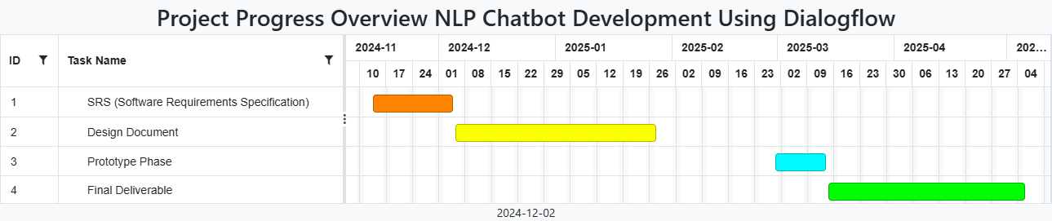

* 1. Project Structure
     1. Team Structure

|  |  |  |  |  |
| --- | --- | --- | --- | --- |
| **Group ID** | **Student Name** | **Student ID** | **Project Name** | **Project Supervisor** |
| F24PROJECT88F2E | Hassam Khan | BC210414987 | NLP Chatbot Development using Dialogflow | Mr. Abdullah Qamar |

* + 1. Project Schedule (Submission Calendar)

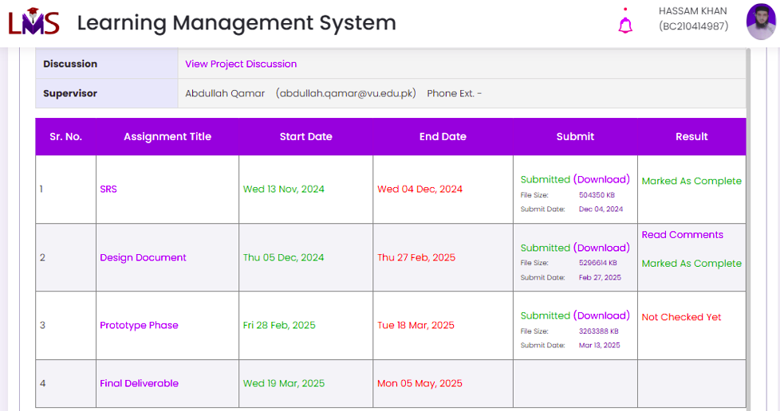

**CHAPTER 3**

Designing the Project

3.1 Introduction

In this design document, I have included several key components to outline the system’s design and architecture, providing a comprehensive blueprint for the development of the AI-powered chatbot.

**Entity Relationship Diagram (ERD)**

The Entity Relationship Diagram (ERD) is one of the primary components, representing the database structure and showing how entities such as users, orders, and reservations are related to each other. This diagram helps ensure that the data is structured in a way that promotes smooth data flow and maintains integrity throughout the system. By clearly defining the relationships between these entities, it assists in organizing the database to handle queries and operations efficiently.

**Sequence Diagrams**

The Sequence Diagrams serve another crucial purpose by illustrating the interaction between users and the system over time. These diagrams highlight the sequence of events during various processes like placing an order or making a reservation. They are essential for understanding how the system behaves in real-time and how different components of the chatbot interact with one another. This is critical for visualizing the flow of user requests and system responses, providing insights into how data is processed step by step.

**Architecture Design Diagram**

The Architecture Design Diagram provides a high-level view of the system, illustrating the components, their relationships, and the technologies used across the backend, frontend, and database layers. This diagram helps visualize how the different parts of the chatbot system will communicate with each other and interact within the overall architecture. It acts as a roadmap to guide the development process, ensuring that all system components fit together smoothly and efficiently.

**Class Diagram**

The Class Diagram focuses on breaking down the system into manageable and reusable components by outlining the various classes, their attributes, and methods. It helps in understanding how each class will function and how they will work together within the overall system. By identifying the relationships and behaviors of the system's objects, this diagram makes the development process more modular and scalable.

**Database Design**

The Database Design section goes into detail about the structure of the database, defining tables, columns, and relationships. This ensures that data is stored and retrieved efficiently, with the relationships between different pieces of information clearly defined. A well-organized database design is essential for ensuring that the chatbot can process queries and handle user interactions effectively.

**Interface Design**

The Interface Design section focuses on the user interface components, ensuring that the chatbot is intuitive and user-friendly. This section outlines how the user will interact with the system and what their experience will be like. It considers user needs and ensures that the chatbot’s interface is simple, responsive, and accessible, ultimately enhancing the customer experience.

**Test Cases**

Finally, the Test Cases section provides a detailed testing strategy that outlines different scenarios to ensure that the system works as expected. By testing each component and functionality, the system can be validated to meet the defined requirements and ensure that it performs as intended. This section ensures that potential issues are identified early in the development process, reducing the risk of errors in the final product.

**Purpose of the Design Phase**

The purpose of this design phase is to provide a detailed plan that guides the development of the system. It ensures that the architecture is well-organized, the database is structured efficiently, and the user interface is intuitive. This phase is vital for laying a strong foundation for the project by clarifying the system’s components and how they will interact. By defining these elements early, the design document minimizes risks, enhances clarity for the development team, and streamlines the overall development process. It also provides a clear roadmap for the entire software development lifecycle, ensuring the system is built according to the specified requirements and is executed efficiently.

3.2 purpose

The **Purpose** of this design document is to provide a clear, comprehensive blueprint for the development and implementation of an AI-powered chatbot for a restaurant. The primary objective is to define the system architecture, design structure, and key components, ensuring that the system will meet user requirements efficiently and effectively. The design document aims to outline the following:

1. **System Architecture:** Describes the overall architecture of the chatbot, including how different components (backend, frontend, and database) will interact with each other.
2. **Database Structure:** Defines how data will be stored and managed in the system, including details about tables, relationships, and entities.
3. **User Interface Design:** Establishes the guidelines for creating an intuitive and user-friendly interface that will enhance the customer experience.
4. **Testing Strategy:** Specifies the approach for testing each component of the chatbot to ensure that the system performs according to the defined requirements.
5. **Development Roadmap:** Provides a clear and actionable plan for developing and deploying the chatbot, minimizing risks and ensuring smooth implementation.

By clarifying these elements, this document will guide the development process, ensuring that the chatbot is functional, user-friendly, and scalable for future enhancements.

3.3 scope

The **Scope** of this design phase includes the following components:

1. **User Interaction:** The chatbot will interact with users to perform tasks such as placing orders, making reservations, answering frequently asked questions (FAQs), and providing restaurant-related information.
2. **Natural Language Processing (NLP):** The system will use Dialogflow, a cloud-based NLP service, to process user inputs and generate appropriate responses in natural language, simulating human-like conversations.
3. **Backend Services:** Python will be used for backend development to handle business logic, process requests, and integrate with the database.
4. **Frontend Development:** The chatbot interface will be built using HTML, CSS, and JavaScript, providing a seamless, interactive experience for users on both desktop and mobile devices.
5. **Database Management:** MySQL will be used to store essential data, including user orders, reservations, customer details, and FAQs.
6. **Security Features:** The system will incorporate secure authentication and data encryption to ensure the protection of user information and data integrity.
7. **Testing and Validation:** The system will undergo comprehensive testing to validate functionality, performance, and usability before deployment.
8. **Exclusions:** The design document does not cover detailed implementation or deployment specifics such as cloud hosting configurations or third-party service integrations beyond the chatbot interface, Dialogflow, and MySQL database.

The scope ensures that all major components necessary for building a functional, interactive chatbot system are addressed and outlined in this phase.

* 1. definitions, acronyms and abbreviations

|  |  |  |
| --- | --- | --- |
| **Term** | **Acronym** | **Definition** |
| **Entity Relationship Diagram** | ERD | A diagram that visually represents the data model and shows the relationships between entities like users, orders, and reservations. |
| **Sequence Diagram** |  | A visual representation of the sequence of interactions between system components over time (e.g., when a user places an order). |
| **Architecture Design Diagram** |  | A high-level diagram that illustrates system components, their relationships, and the technologies used in the frontend, backend, and database. |
| **Class Diagram** |  | A design diagram showing system classes, their attributes, methods, and relationships, used to structure and modularize the system. |
| **Database** |  | An organized collection of structured data designed to store and manage chatbot-related information efficiently. |
| **Dialogflow** |  | A conversational platform from Google used to design and manage the chatbot’s NLP functionality and interactions. |
| **Intent** |  | A component in Dialogflow representing the goal behind a user’s input, essential in designing system responses and actions. |
| **Entity** |  | Structured data points extracted from user inputs, important for designing input handling and database mapping. |
| **Webhook** |  | A tool that connects Dialogflow with backend servers or databases, used in system design to handle dynamic responses. |
| **User Interface** | UI | The design layer of the chatbot that users interact with; includes layouts, buttons, input fields, and accessibility features. |

3.5 Dynamic Model: Sequence Diagrams

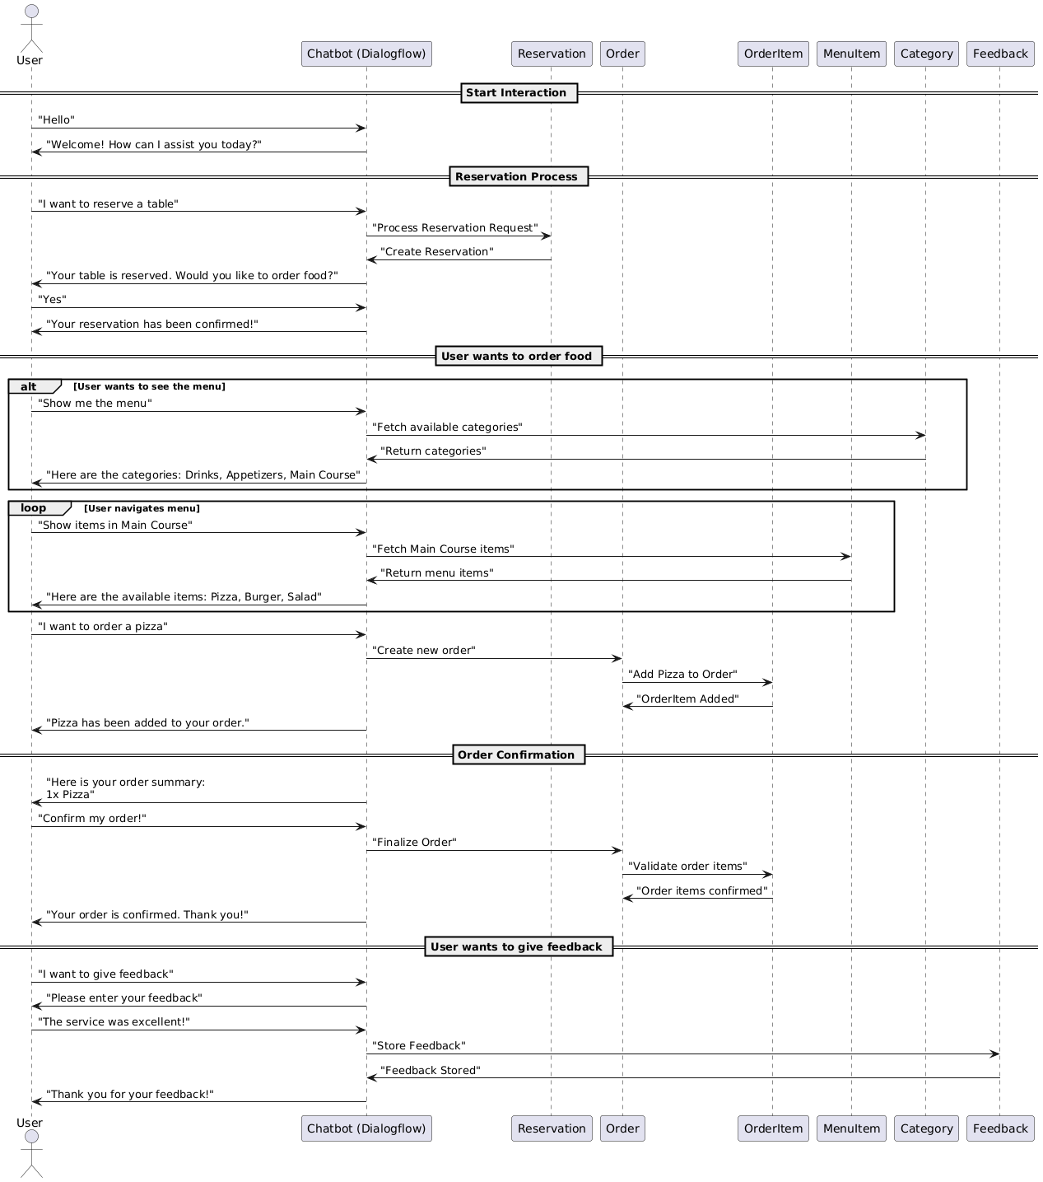

3.6 Object Model/Logical Model: Class Diagram

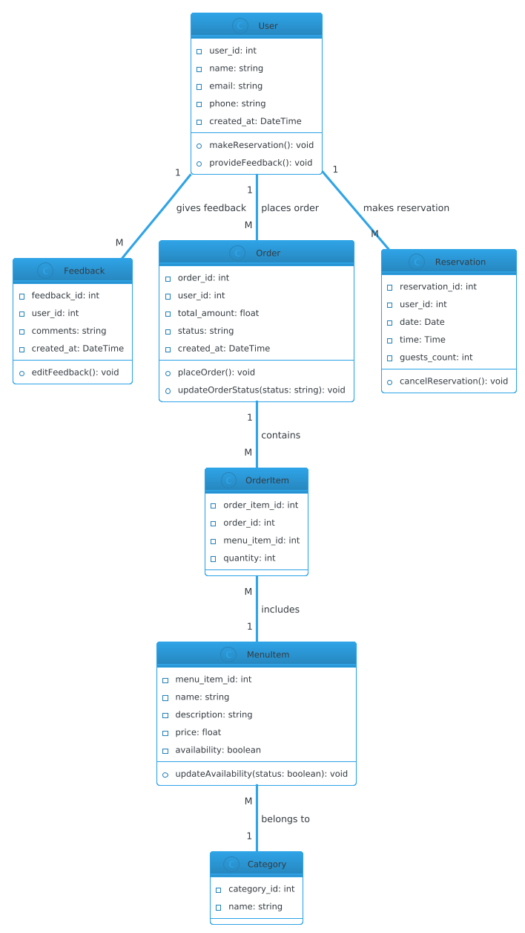

* 1. Database Model (Database Diagram)

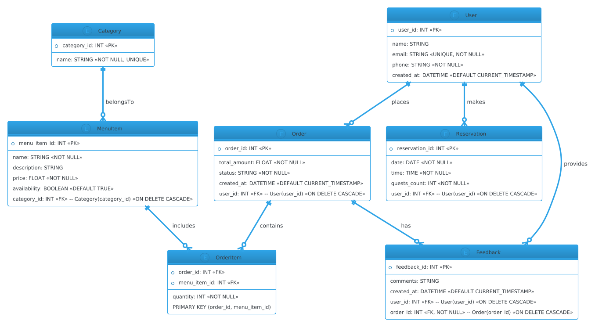

3.8 Graphical User Interfaces

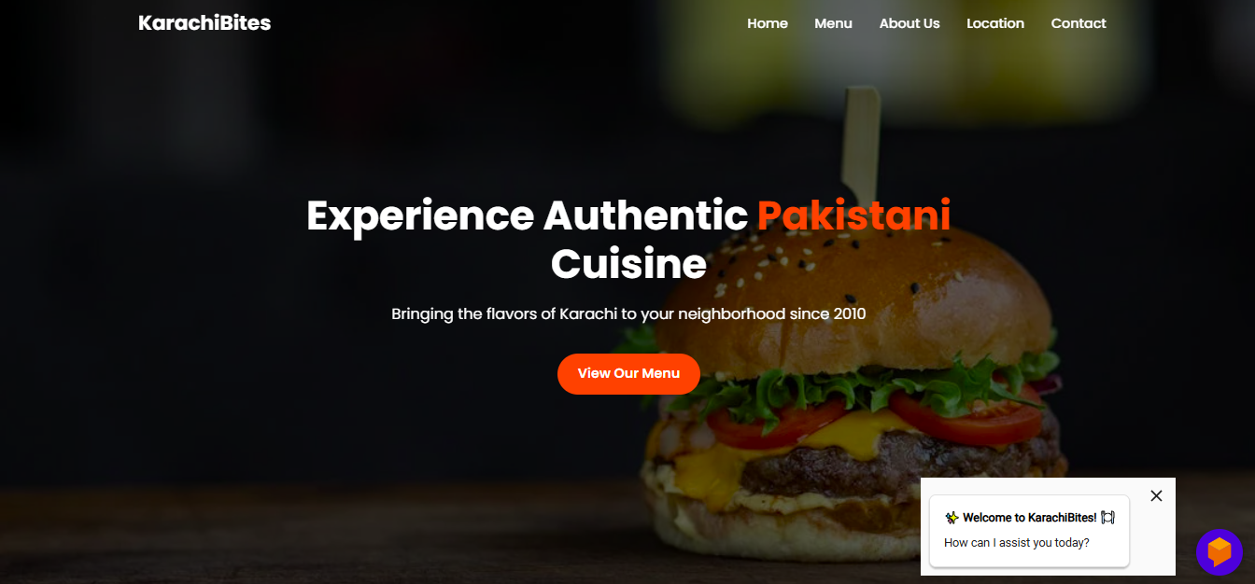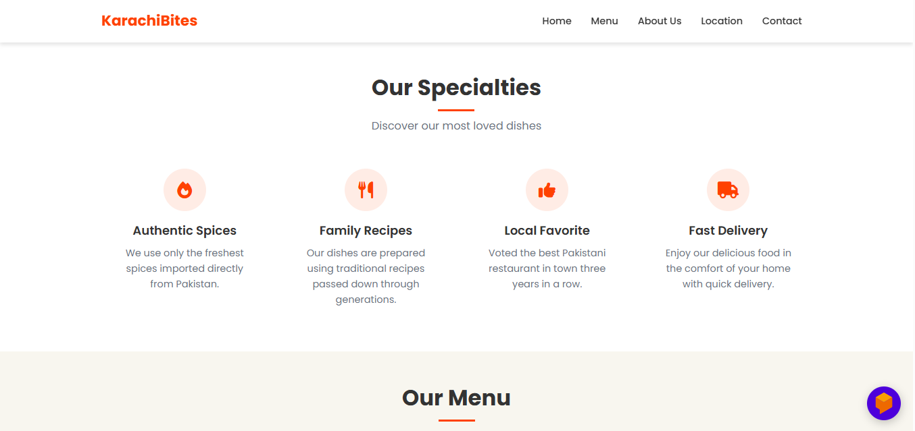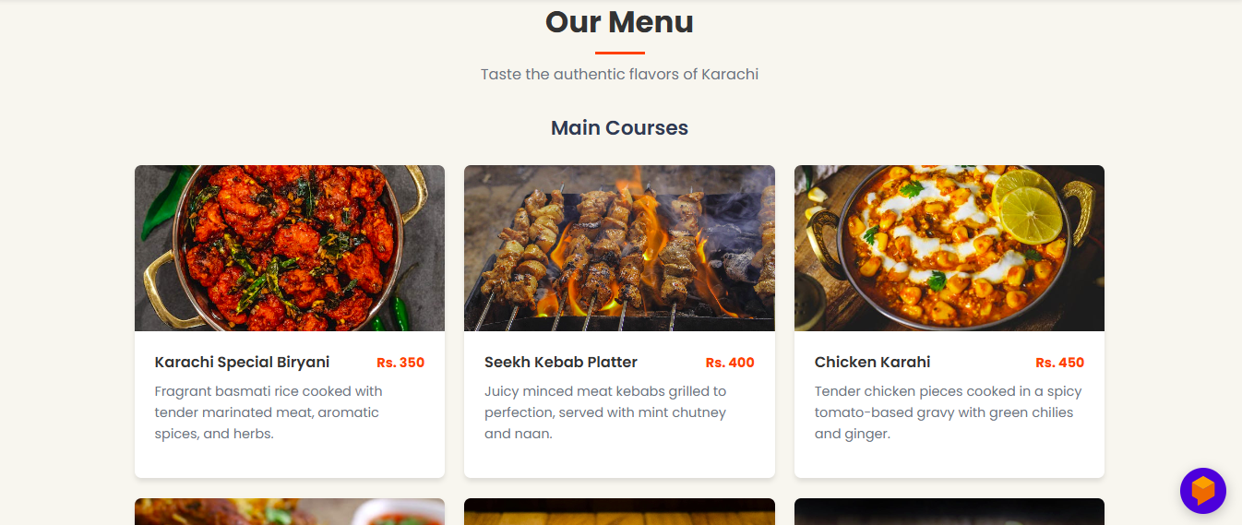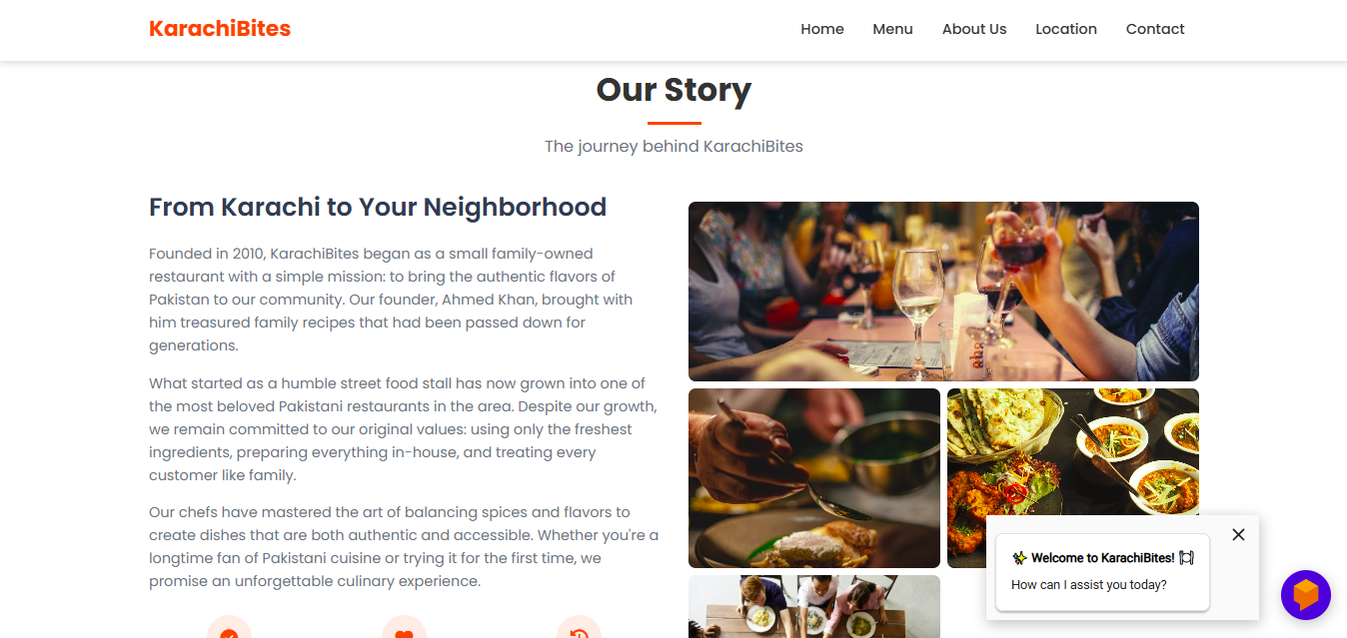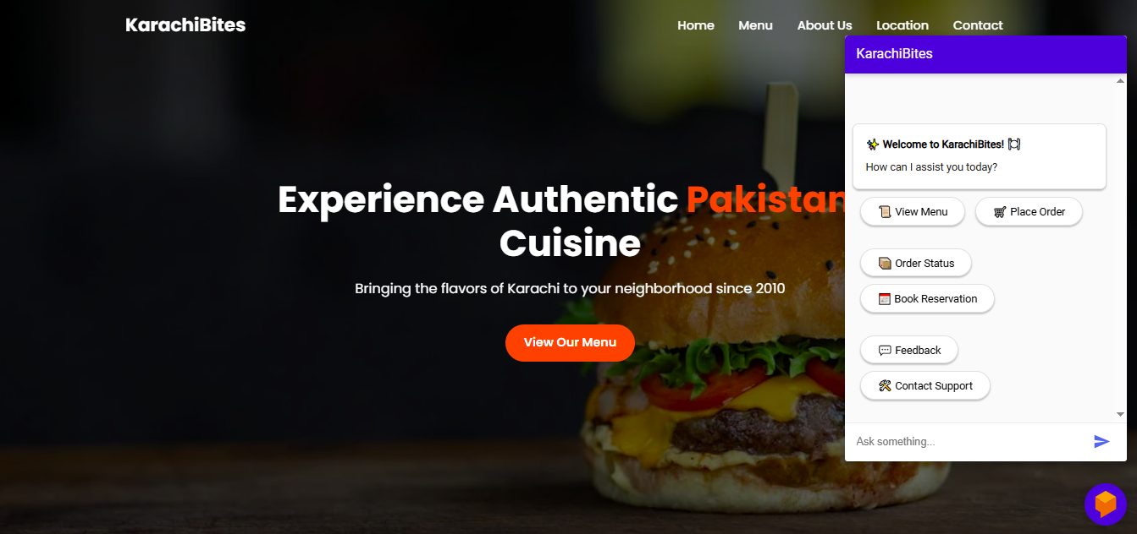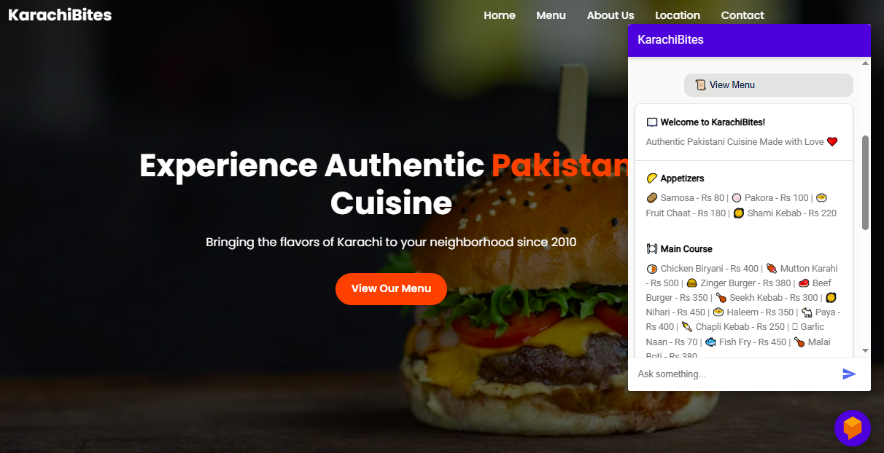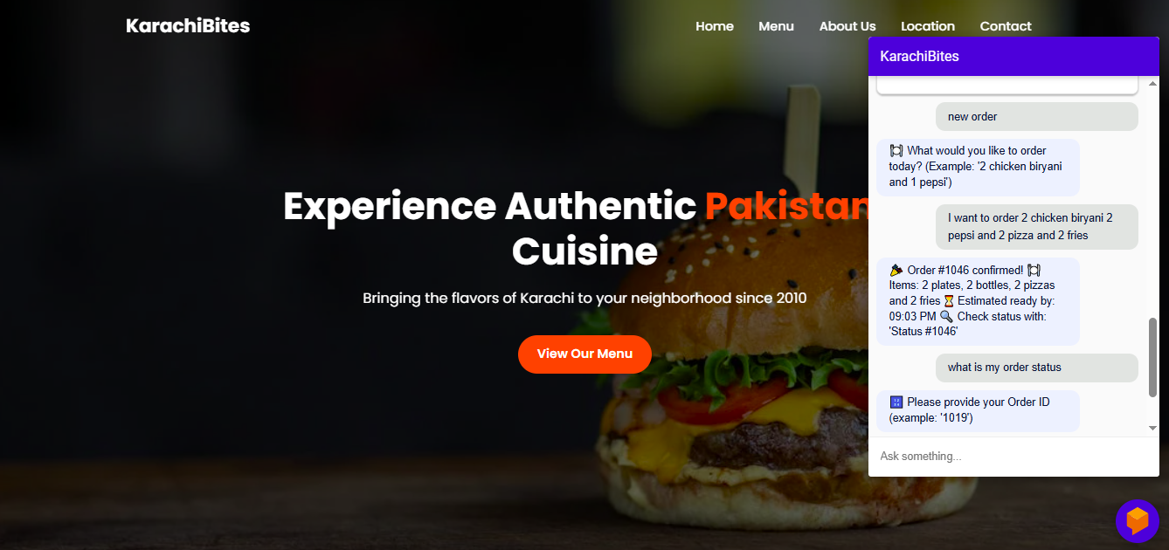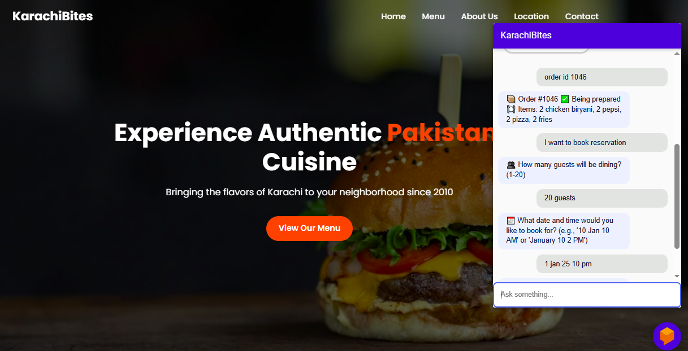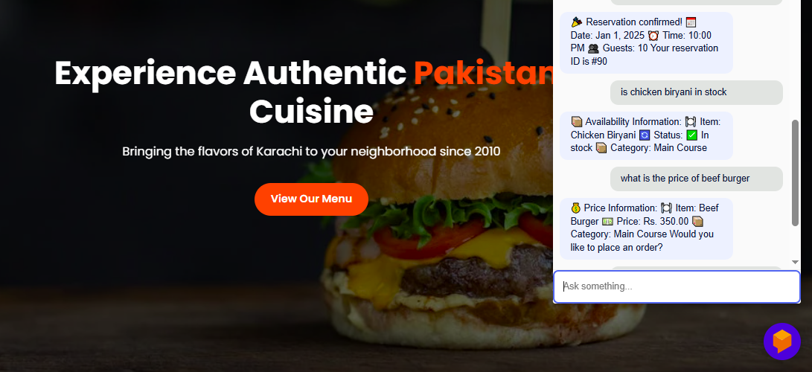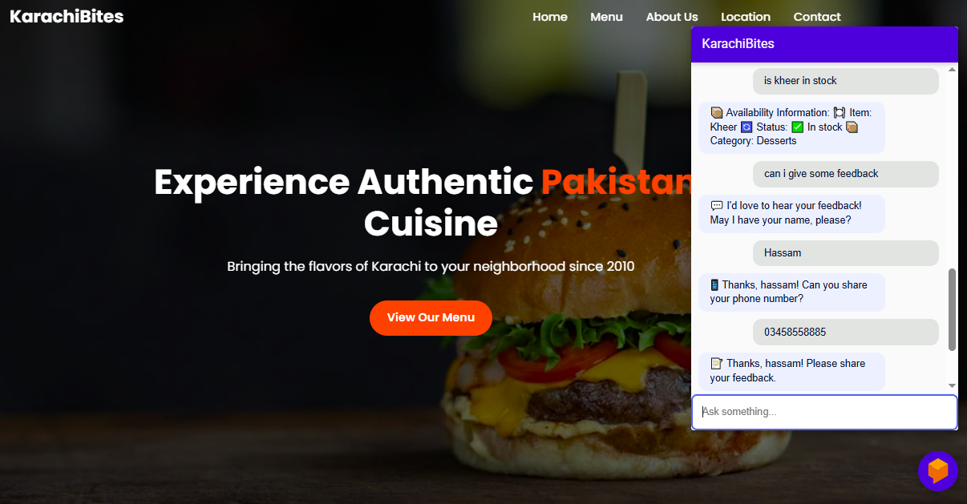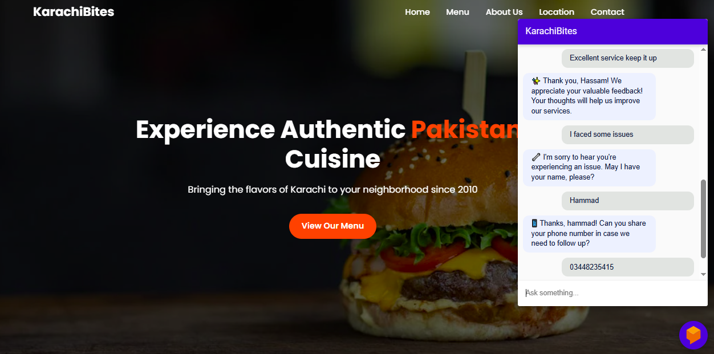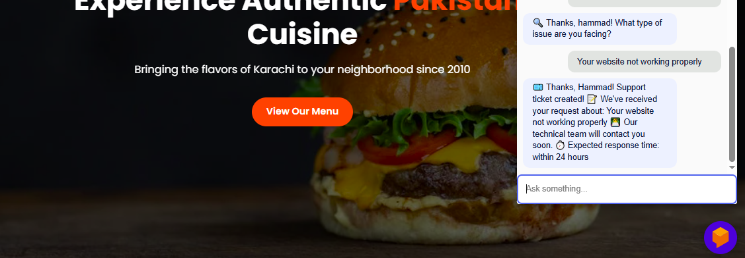

**CHAPTER 4**

Development

4.1 Development plan (Architecture Diagram)

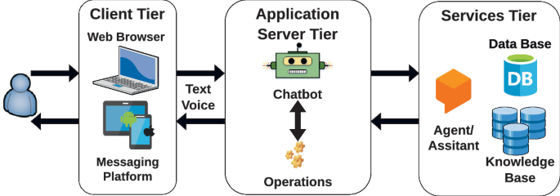

**REFERENCES**

• Dialogflow. (n.d.). Dialogflow documentation. Google Cloud. Retrieved May 5, 2025, from https://cloud.google.com/dialogflow/docs

• MySQL. (n.d.). MySQL 8.0 reference manual. Oracle. Retrieved May 5, 2025, from <https://dev.mysql.com/doc/>

• W3Schools. (n.d.). SQL tutorial. Retrieved May 5, 2025, from https://www.w3schools.com/sql/

• MDN Web Docs. (n.d.). Working with JSON. Mozilla. Retrieved May 5, 2025, from <https://developer.mozilla.org/en-US/docs/Learn/JavaScript/Objects/JSON>

• Diagrams.net. (n.d.). Draw.io – Free diagram software. Retrieved May 5, 2025, from https://app.diagrams.net/

• Visual Studio Code. (n.d.). Code editing. Redefined. Microsoft. Retrieved May 5, 2025, from <https://code.visualstudio.com/>

• Jurafsky, D., & Martin, J. H. (2021). Speech and language processing (3rd ed.). Pearson.

• GitHub. (n.d.). Dialogflow chatbot template. Retrieved May 5, 2025, from <https://github.com/dialogflow>

• Freepik. (n.d.). UI/UX chatbot illustrations. Retrieved May 5, 2025, from <https://www.freepik.com>

• Stack Overflow. (n.d.). Community discussions on chatbot development. Retrieved May 5, 2025, from <https://stackoverflow.com>

**APPENDIX**

|  |  |  |  |
| --- | --- | --- | --- |
| **Appendix No** | **Chapter & Section** | **Title** | **Description** |
| A1 | Chp No. 1 - GATHERING & ANALYZING INFO - Sec 1.5.1 | Use Case Diagrams | Diagrams that visually represent the functional requirements of the chatbot system, showing interactions between users and the system. |
| A2 | Chp No. 1 - GATHERING & ANALYZING INFO - Sec 1.5.2 | Usage Scenarios | Text-based examples that describe how users will interact with the chatbot in different real-life situations, such as placing an order or asking FAQs. |
| A3 | Chp No. 1 - GATHERING & ANALYZING INFO - Sec 1.6.1 to 1.6.4 | Supplementary Requirements | Detailed usability, reliability, supportability, and system environment needs for ensuring smooth operation and support for the chatbot system. |
| B1 | Chp No. 2 - PLANNING THE PROJECT - Sec 2.6 | Work Plan | A structured plan outlining the development phases, tasks, and timeline to complete the project efficiently. |
| B2 | Chp No. 2 - PLANNING THE PROJECT - Sec 2.7.1 | Team Structure | Information about the team members involved in the project and their assigned roles and responsibilities. |
| B3 | Chp No. 2 - PLANNING THE PROJECT - Sec 2.7.2 | Project Schedule (Submission Calendar) | A timeline that includes important deadlines and submission dates for each project milestone. |
| C1 | Chp No. 3 - DESIGNING THE PROJECT - Sec 3.5 | Sequence Diagrams | Diagrams that illustrate the sequence of interactions between the user, chatbot, and database in handling different scenarios. |
| C2 | Chp No. 3 - DESIGNING THE PROJECT - Sec 3.6 | Class Diagram | A representation of the system’s structure in terms of classes, attributes, and methods relevant to the chatbot application. |
| C3 | Chp No. 3 - DESIGNING THE PROJECT - Sec 3.7 | Database Diagram | A visual layout of the database design showing tables, fields, and relationships used to store chatbot data like users, orders, and reservations. |
| C4 | Chp No. 3 - DESIGNING THE PROJECT - Sec 3.8 | Graphical User Interfaces (UI Screens) | Screenshots or mockups of the user interface design for both customers and administrators interacting with the chatbot. |
| D1 | Chp No. 4 - DEVELOPMENT - Sec 4.1 | Architecture Design Diagram | A high-level system architecture diagram that outlines how different components (frontend, backend, database) interact in the project. |